

Provided by Leah Beman

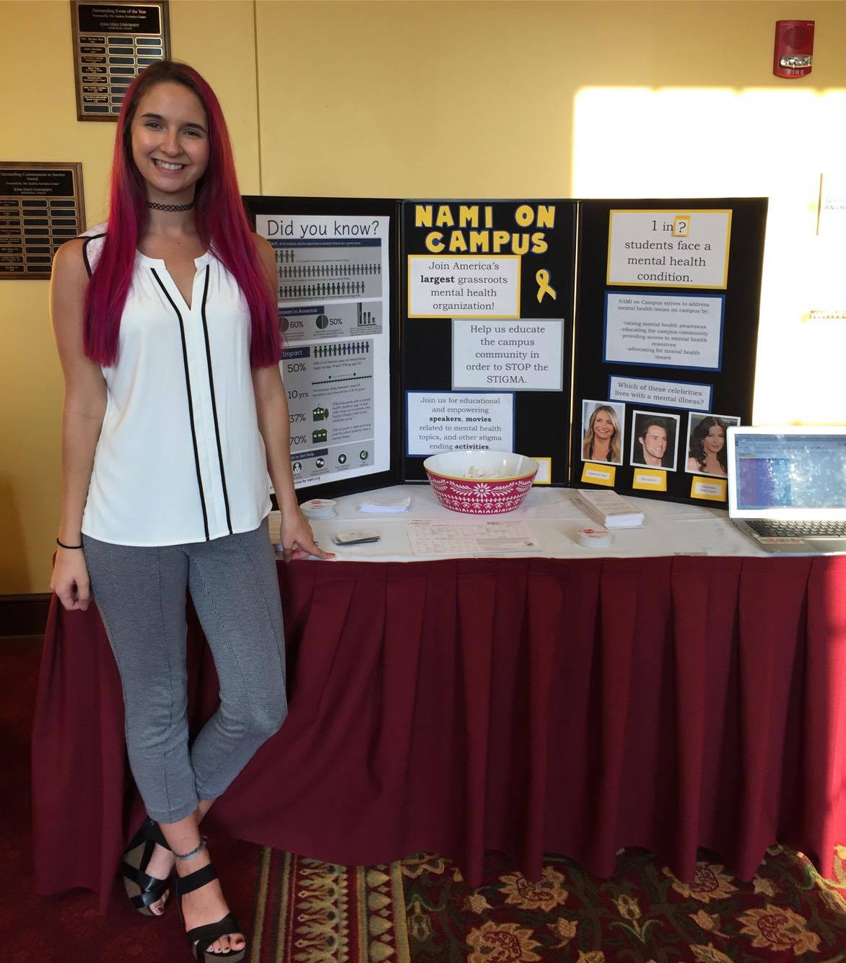

Provided by NAMI

<http://www.iowastatedaily.com/news/article_036a4108-a3bc-11e7-a1f6-677d33b8e4c8.html>